+

**Experiment (1)**

| **Name:** Norhan Reda Abd El-wahed Ahmed | **Sec: 2** | **B. N. 30** |
| --- | --- | --- |

**Experiment 1 Results sheet:**

1. a) Code and plot for x[n]

>> n=[-3:7];

>> x=zeros(length(n),1);

>> x=[0 0 0 2 0 1 -1 3 0 0 0];

>> stem(n,x);

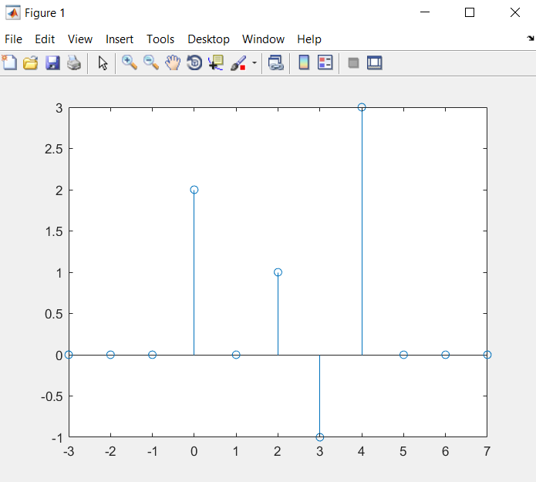

b) Write the definition of the new axis and plot the signal in the table below:

| Y1  (n+2)  >> stem(n+2,x); |
| --- |
| Y2  (n-1)  stem(n-1,x); |
| Y3  (-n)  stem(-n,x); |
| Y4  (-(n-1))=(-n+1)  >> stem(-(n-1),x); |

2- a)

| M | Plotting | Fundamental period |
| --- | --- | --- |
| 4 |  | 3 |
| 5 |  | 12 |
| 7 |  | 12 |
| 10 |  | 6 |

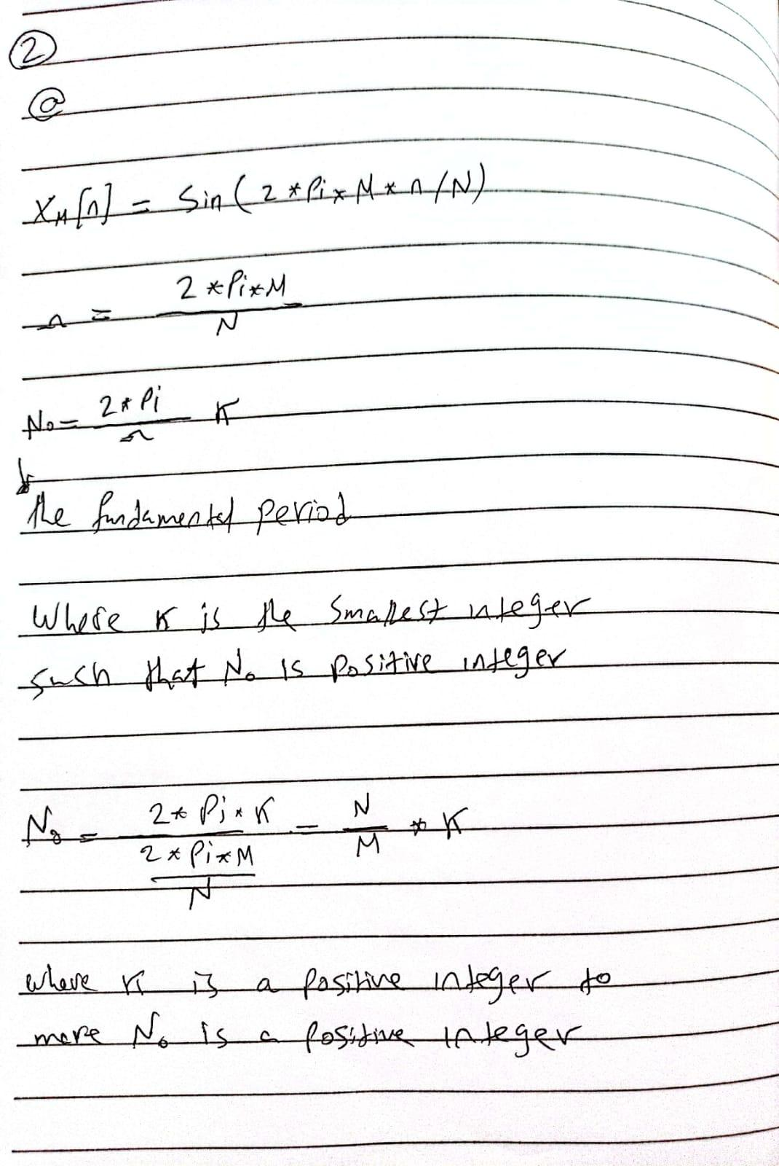

2- b)

| Stem of x | K |
| --- | --- |
|  | 1 |
|  | 2 |
|  | 4 |
|  | 6 |

There are three unique plots because at k=1 and k=6 have the same plot .

Period is five and difference between k=1 and k=6 is one period so k=6 is the same signal as k=1 but after one period

3)

| n=[0:9];  x=sin(2*pi*1/10*n);  stem(n,x);  Etot=sum(x.^2);  Ptot=Etot/length(x);      Eoneperiod= 5.000000000000001  Ptotal= 0.500000000000000  Etotal for periodic function = inf | a |
| --- | --- |
| n=[0:12];  x=sin(2*pi*1/10*n);  stem(n,x);  Etot=sum(x.^2);  Ptot=Etot/length(x);    Etotal= 6.250000000000000  Ptotal=0 (aperiodic ) | B |
| n=[0:1002];  x=sin(2*pi*1/10*n);  stem(n,x);  Etot=sum(x.^2);  % Ptot=Etot/length(x);%    Etotal= 501.2500  Ptotal=0 (aperiodic ) | C |

**Comments**

For b and c they are aperiodic signals because the are on a specific interval in which they aren’t periodic so the total power is zero according to the relation

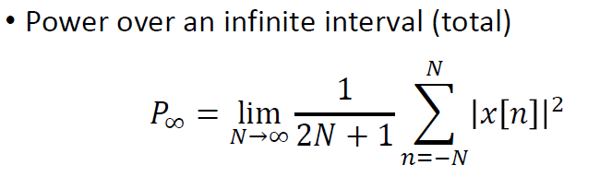

And they have a finite energy

**Codes**

**1-**

**a-**

>> nx=[-3:7];

>> x=zeros(length(nx),1);

>> x=[0 0 0 2 0 1 -1 3 0 0 0];

>> stem(nx,x);

**b-**

Y1

>> nx=[-3:7];

>> x=zeros(length(nx),1);

>> x=[0 0 0 2 0 1 -1 3 0 0 0];

>> stem(nx+2,x);

Y2

>> nx=[-3:7];

>> x=zeros(length(nx),1);

>> x=[0 0 0 2 0 1 -1 3 0 0 0];

>>stem(nx-1,x);

Y3

>> nx=[-3:7];

>> x=zeros(length(nx),1);

>> x=[0 0 0 2 0 1 -1 3 0 0 0];

>>stem(-nx,x);

Y4

>> nx=[-3:7];

>> x=zeros(length(nx),1);

>> x=[0 0 0 2 0 1 -1 3 0 0 0];

>> stem(-(nx-1),x);

**2-**

**a-**

N=12;

M=4;

n = [0:2*N - 1];

x=sin(2*pi*M*n/N);

stem(n,x);

**/////////////////////////**

N=12;

M=5;

n = [0:2*N - 1];

x=sin(2*pi*M*n/N);

stem(n,x);

////////////////////////

N=12;

M=7;

n = [0:2*N - 1];

x=sin(2*pi*M*n/N);

stem(n,x);

///////////////////////////

N=12;

M=10;

n = [0:2*N - 1];

x=sin(2*pi*M*n/N);

stem(n,x);

///////////////////////////

**b-**

n=[0:9];

w=2*pi /5;

k=1;

x=sin(w*k*n);

stem(n,x);

///////////////

n=[0:9];

w=2*pi /5;

k=2;

x=sin(w*k*n);

stem(n,x);

////////////////

n=[0:9];

w=2*pi /5;

k=4;

x=sin(w*k*n);

stem(n,x);

/////////////////

n=[0:9];

w=2*pi /5;

k=6;

x=sin(w*k*n);

stem(n,x);

**3-**

**a-**

n=[0:9];

x=sin(2*pi*1/10*n);

stem(n,x);

Etot=sum(x.^2);

Ptot=Etot/length(x);

**b-**

n=[0:12];

x=sin(2*pi*1/10*n);

stem(n,x);

Etot=sum(x.^2);

**c-**

n=[0:1002];

x=sin(2*pi*1/10*n);

stem(n,x);

Etot=sum(x.^2);